Technical Coding Research Innovation, Navi Mumbai,

Maharashtra, India-410206

# (HR_Employee_Attrition_Analysis)

A Case-Study Submitted for the requirement of

**Technical Coding Research Innovation**

For the Internship Project work done during

**DATA SCIENCE WITH MACHINE LEARNING AND PYTHON INTERNSHIP PROGRAM**

by

AFRAJ ANIS MANSURI (TCRIB2R202)

Rutuja Doiphode

CO-FOUNDER &CEO

TCR innovation.

Preparation of Papers in Two-Column Format

for Conference Proceedings Published by IEEE[1]

|  |  |
| --- | --- |
| Bart Simpson and Homer Simpson | Monkey King, Bajie Zhu and Seng Tang |
| *Department of Nuclear Power Engineering* | *Department of Intelligent Robotics* |
| *University of Springfield* | *University of Huaguoshan* |
| *Springfield, Nostate 12345, USA* | *Huaguoshan, Jileshijie Province, China* |
| {bart.simpson & homer.simpson}@uspringfield.edu | monkey.king@uhuaguoshan.edu.cn |

***Abstract* - These instructions give you the basic guidelines for preparing papers for IEEE conference proceedings.**

***Index Terms - List key index terms here. No mare than 5.***

I. Introduction

Your goal is to simulate the usual appearance of papers in *IEEE conference proceedings*. For items not addressed in these instructions, please refer to the last issue of your conference's proceedings for reference or ask your conference Publications Chair for instructions.

*A. Preparing Your Paper*

*1) Paper Size*: Prepare your paper in full-size format on US letter size paper (8.5 by 11 inches).

*2) Type Sizes and Typefaces*: Follow the font type sizes specified in Table I. The font type sizes are given in points, same as in the MS Word font size points. Times New Roman is the preferred font.

*3) Paper Margins*: Paper margins on the US letter size paper are set as follows: top = 0.75 inches, bottom = 1 inch, side = 0.625 inches. Each column measures 3.5 inches wide, with a 0.25-inch gap between the two columns.

*4) Paper Styles*: Left- and right-justify the columns. On the last page of your paper, adjust the lengths of the columns so that they are equal. Use automatic hyphenation and check spelling and grammar. Use high resolution (300dpi or above) figures, plots, drawings and photos for best printing result.

TABLE I

Type Size for Papers

|  |  |  |  |
| --- | --- | --- | --- |
| Type size (pts.) | Appearance | | |
| Regular | Bold | Italic |
| 6 | Table superscripts |  |  |
| 8 | Section titlesa, references, tables, table namesa, table captions, figure captions, footnotes, text subscripts, and superscripts |  |  |
| 9 |  | Abstract, Index Terms |  |
| 10 | Authors' affiliations, main text, equations, first letter in section titlesa |  | Subheading |
| 11 | Authors' names |  |  |
| 22 | Paper title |  |  |

aUppercase

*B. Preparing Your PDF Paper for IEEE Xplore©*

Detailed instructions on how to prepare PDF files of your papers for IEEE *Xplore*© can be found at

http://www.ieee.org/pubs/confpubcenter

PDF job setting files for Acrobat versions 4, 5 and 6 can be found for downloading from the above webpage as well. The instructions for preparing PDF papers for IEEE *Xplore*© must be strictly followed.

II. Helpful Hints

*A. Figures and Tables*

Try to position figures and tables at the tops and bottoms of columns and avoid placing them in the middle of columns. Large figures and tables may span across both columns. Figure captions should be centered below the figures; table captions should be centered above. Avoid placing figures and tables before their first mention in the text. Use the abbreviation “Fig. #,” even at the beginning of a sentence.

Figure axis labels are often a source of confusion. Use words rather than symbols. For example, as shown in Fig. 1, write “Magnetization,” or “Magnetization (M)” not just “M.” Put units in parentheses. Do not label axes only with units. In the example, write “Magnetization (A/m)” or “Magnetization (Am-1).” Do not label axes with a ratio of quantities and units. For example, write “Temperature (K),” not “Temperature/K.”

Multipliers can be very confusing. Write “Magnetization (kA/m)” or “Magnetization (103 A/m).” Figure labels should be legible, at 8-point type.

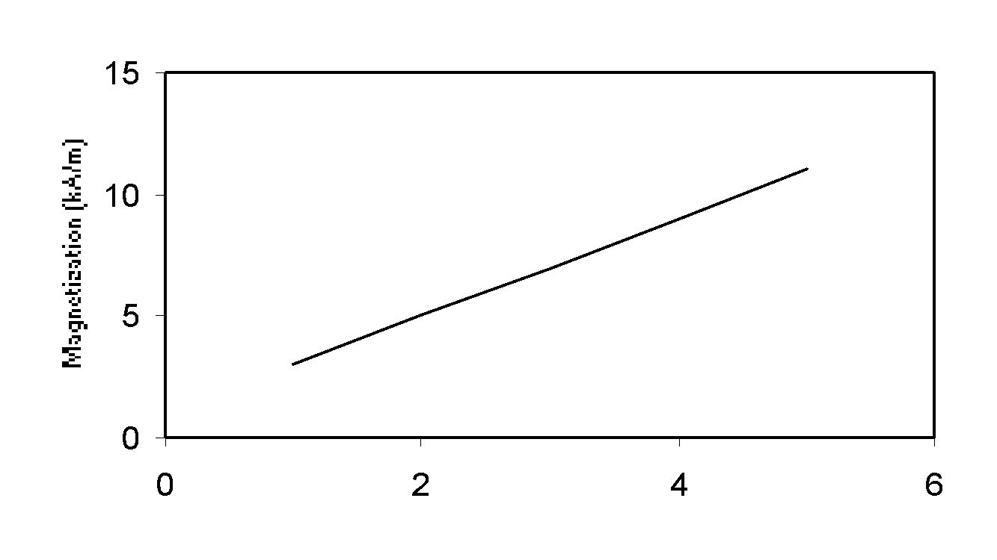

Magnetization (kA/m)

Applied Field (103 A/m)

Fig. 1 Magnetization as a function of applied field.

Note how the caption is centered in the column.

*B. References*

Number citations consecutively in square brackets [1]. Punctuation follows the bracket [2]. Refer simply to the reference number, as in [3]. Use “Ref. [3]” or “Reference [3]” at the beginning of a sentence: “Reference [3] was the first …”

Number footnotes separately in superscripts. Place the actual footnote at the bottom of the column in which it was cited. Do not put footnotes in the reference list. Use letters for table footnotes (see Table I). *IEEE Transactions* no longer use a journal prefix before the volume number. For example, use “*IEEE Trans. Magn.*, vol. 25,” not “vol. MAG-25.”

Give all authors’ names; use “et al.” if there are six authors or more [4]. Papers that have not been published, even if they have been submitted for publication, should be cited as “unpublished” [4]. Papers that have been accepted for publication should be cited as “in press” [5]. In a paper title, capitalize the first word and all other words except for conjunctions, prepositions less than seven letters, and prepositional phrases.

For papers published in translated journals, first give the English citation, then the original foreign-language one [6].

*C. Abbreviations and Acronyms*

Define abbreviations and acronyms the first time they are used in the text, even if they have been defined in the abstract. Abbreviations such as IEEE, SI, MKS, CGS, ac, dc, and rms do not have to be defined. Do not use abbreviations in the title unless they are unavoidable.

*D. Equations*

Number equations consecutively with equation numbers in parentheses flush with the right margin, as in (1). To make your equations more compact, you may use the solidus (/) and the exp function, etc. Italicize Roman symbols for quantities and variables, but not Greek symbols. Use an en dash (–) rather than a hyphen for a minus sign. Use parentheses to avoid ambiguities in denominators. Punctuate equations with commas or periods when they are part of a sentence, as in

. (1)

Symbols in your equation should be defined before the equation appears or immediately following. Cite equations using “(1),” not Eq. (1)” or “equation (1),” except at the beginning of a sentence: “Equation (1) is …”

*E. Other Recommendations*

The Roman numerals used to number the section headings are optional. Do not number Acknowledgement and References and begin Subheadings with letters. Use two spaces after periods (full stops). Hyphenate complex modifiers: “zero-field-cooled magnetization.” Avoid dangling participles, such as, “Using (1), the potential was calculated.” Write instead, “The potential was calculated using (1),” or “Using (1), we calculated the potential.”

Use a zero before decimal points: “0.25,” not “.25.” Use “cm3,” not “cc.” Do not mix complete spellings and abbreviations of units: “Wb/m2” or “webers per square meter,” not “webers/m2.” Spell units when they appear in text: “…a few henries,” not “…a few H.” If your native language is not English, try to get a native English-speaking colleague to proofread your paper. Do not add page numbers.

III. Units

Use either SI (MKS) or CGS as primary units. (SI units are encouraged.) English units may be used as secondary units (in parentheses). An exception would be the use of English units as identifiers in trade, such as “3.5-inch disk drive.”

Avoid combining SI and CGS units, such as current in amperes and magnetic field in oersteds. This often leads to confusion because equations do not balance dimensionally. If you must use mixed units, clearly state the units for each quantity that you use in an equation.

IV. Some Common Mistakes

The word “data” is plural, not singular. In American English, periods and commas are within quotation marks, like “this period.” A parenthetical statement at the end of a sentence is punctuated outside of the closing parenthesis (like this). (A parenthetical sentence is punctuated within the parentheses.) A graph within a graph is an “inset,” not an “insert.” The word alternatively is preferred to the word “alternately” (unless you mean something that alternates). Do not use the word “essentially” to mean “approximately” or “effectively.” Be aware of the different meanings of the homophones “affect” and “effect,” “complement” and “compliment,” “discreet” and “discrete,” “principal” and “principle.” Do not confuse “imply” and “infer.” The prefix “non” is not a word; it should be joined to the word it modifies, usually without a hyphen. There is no period after the “et” in the Latin abbreviation “et al.” The abbreviation “i.e.” means “that is,” and the abbreviation “e.g.” means “for example.” An excellent style manual for science writers is [7].

Acknowledgment

The preferred spelling of the word “acknowledgment” in America is without an “e” after the “g.” Try to avoid the stilted expression, “One of us (R. B. G.) thanks …” Instead, try “R.B.G. thanks …” Put sponsor acknowledgments in the unnumbered footnote on the first page.

References

1. M. King, B. Zhu, and S. Tang, “Optimal path planning,” *Mobile Robots*, vol. 8, no. 2, pp. 520-531, March 2001.
2. H. Simpson, *Dumb Robots*, 3rd ed., Springfield: UOS Press, 2004, pp.6-9.
3. M. King and B. Zhu, “Gaming strategies,” in Path Planning to the West, vol. II, S. Tang and M. King, Eds. Xian: Jiaoda Press, 1998, pp. 158-176.
4. B. Simpson, et al, “Title of paper goes here if known,” unpublished.
5. J.-G. Lu, “Title of paper with only the first word capitalized,” *J. Name Stand. Abbrev.*, in press.
6. Y. Yorozu, M. Hirano, K. Oka, and Y. Tagawa, “Electron spectroscopy studies on magneto-optical media and plastic substrate interface,” *IEEE Translated J. Magn. Japan*, vol. 2, pp. 740-741, August 1987 [*Digest 9th Annual Conf. Magnetics Japan*, p. 301, 1982].
7. M. Young, *The Technical Writer’s Handbook*, Mill Valley, CA: University Science, 1989.

1. This work is partially supported by NSF Grant #2003168 to H. Simpson and CNSF Grant #9972988 to M. King.